Clustering

Clustering is dividing data points into homogenous classes or clusters
Points in the same group are as similar as possible
Points in the different groups are as dissimilar as possible

Application of Clustering: Clustering is used in almost all fields
- Clustering is identification of groups of houses on the basis of their value, type and geographical location.
- Clustering is used to study earth quake. Based on the areas hit by earthquake in a region, clustering can help to analyse the next probable location where earth quake can occur.
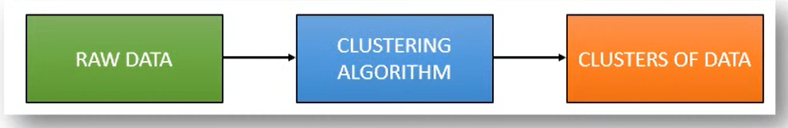
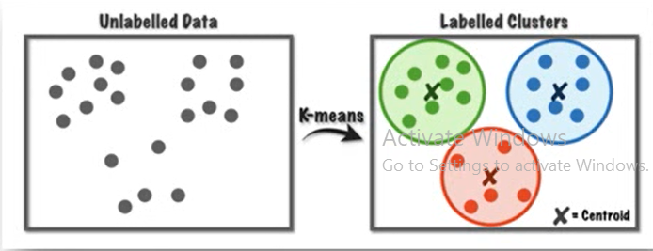

About K-means cluster
A K-means algorithm tries to group similar items in the form of clusters.
The number of groups is represented by k. if K=2 then there will be two clusters
It is a centroid based algorithm where each cluster is associated with centroid
The main aim of the algorithm is to minimize the sum of distances between the data points and their corresponding cluster
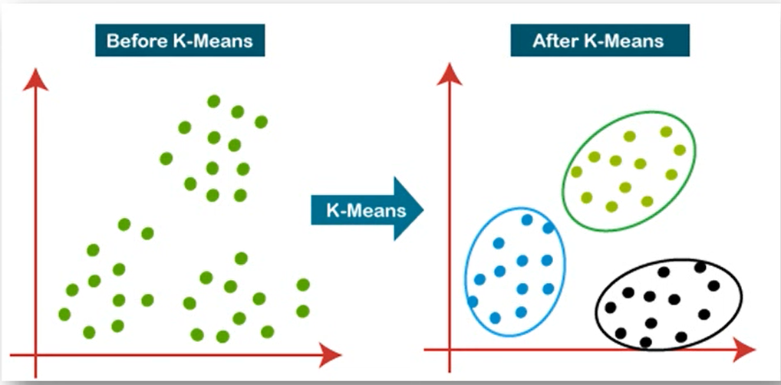

Applications
A Pizza chain wants to open its delivery centers across a city
What do you think would be possible challenges
They need to analyse areas from where pizza is being ordered frequently
They need to analyse how many pizza store has to be opened to cover delivery in the area
They need to figure the locations of pizza stores within all these areas in order to keep the distance between the store and delivery point minimum


K-means algorithm steps
- Select number k to decide number of clusters
- Select random K points or centroids. (It can be other from the input dataset).
- Assign each data point to their closet centroid. Which will forma predefined K cluster
- Calculate variance and place new centroid of each cluster.
- Repeat third step, which means reassign each data point to the new closest centroid of each cluster.
- If any reassignment occurs then go to step 4 or else go to finish.
- Model is ready

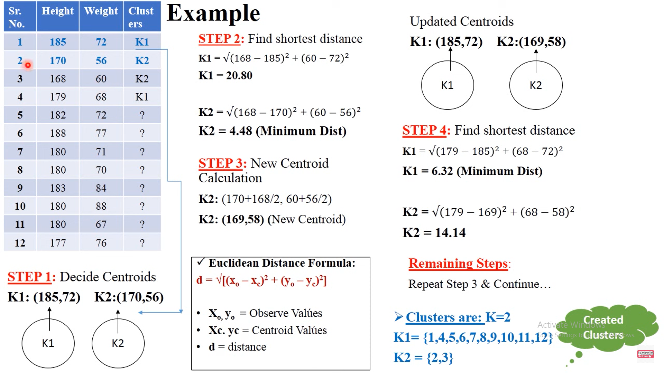

Advantages of K-Means

- It is very simple to implement
- It is scalable to a huge dataset and also faster to large dataset.
- It adapts new examples very frequently
- Generalization of clusters for different sizes and shapes.

Disadvantages of K-Means
- It is sensitive to outliers.
- Choosing the K values manually is a tough job.
- As the number of dimensions increases its scalability decreases.

Numerical on K-Means
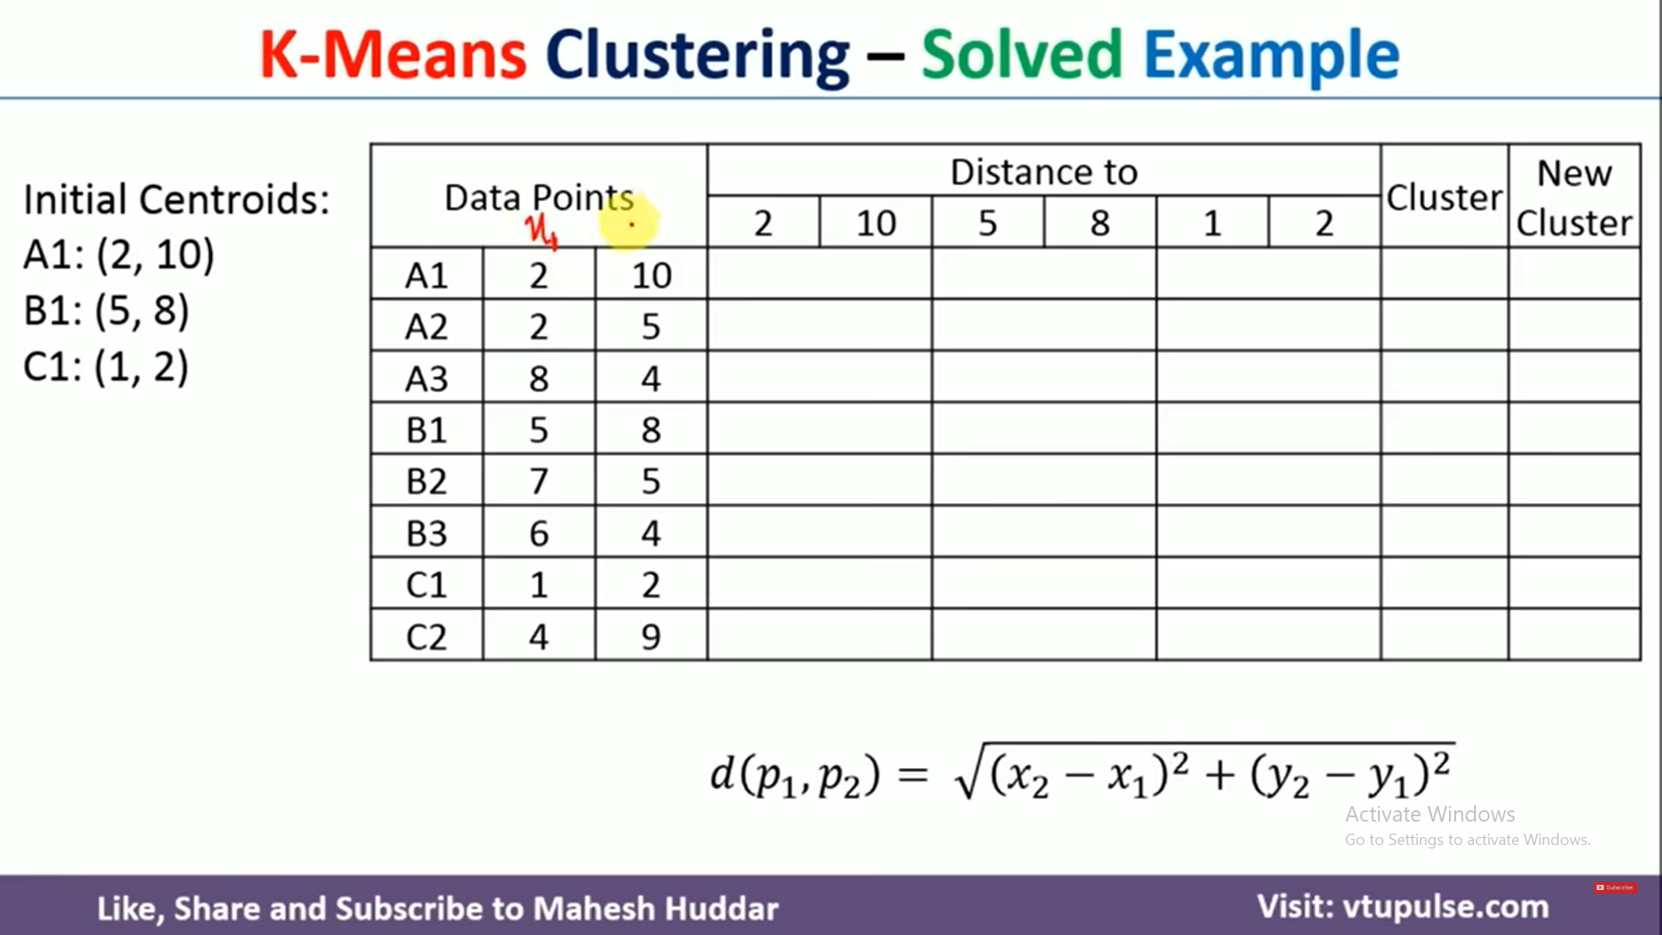

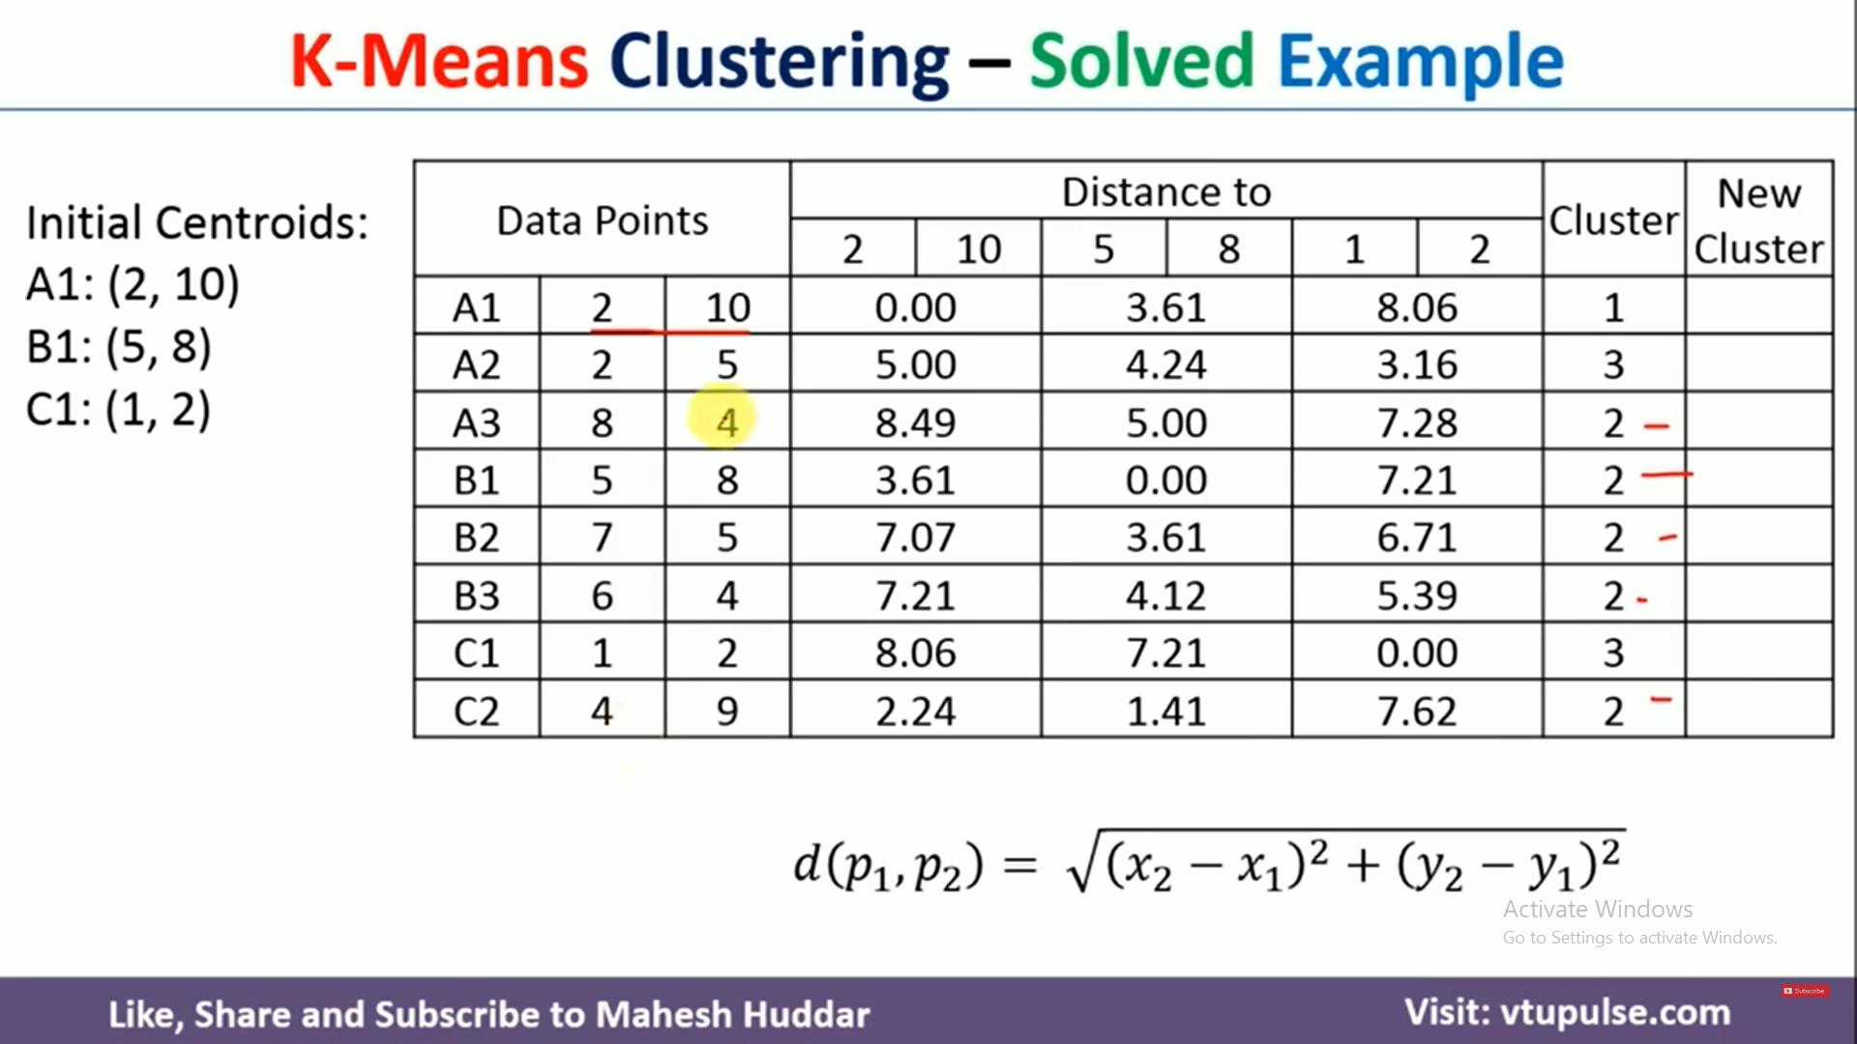

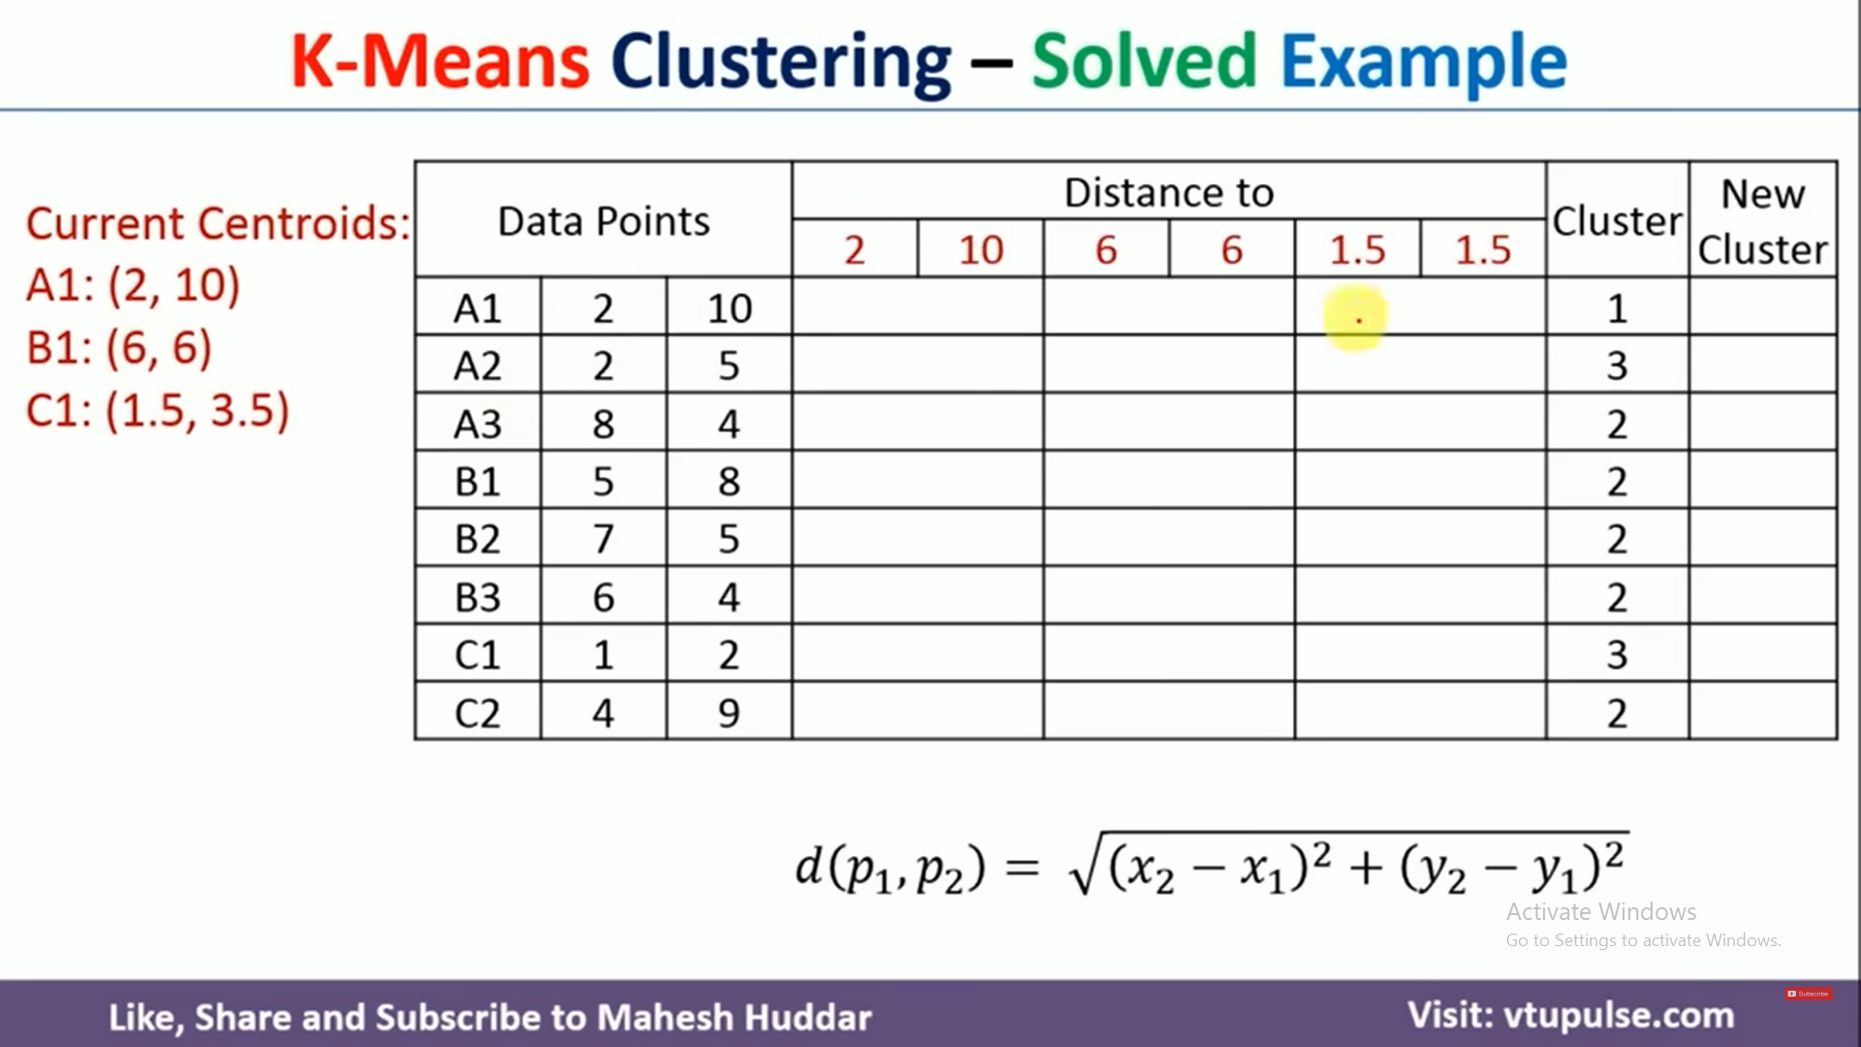

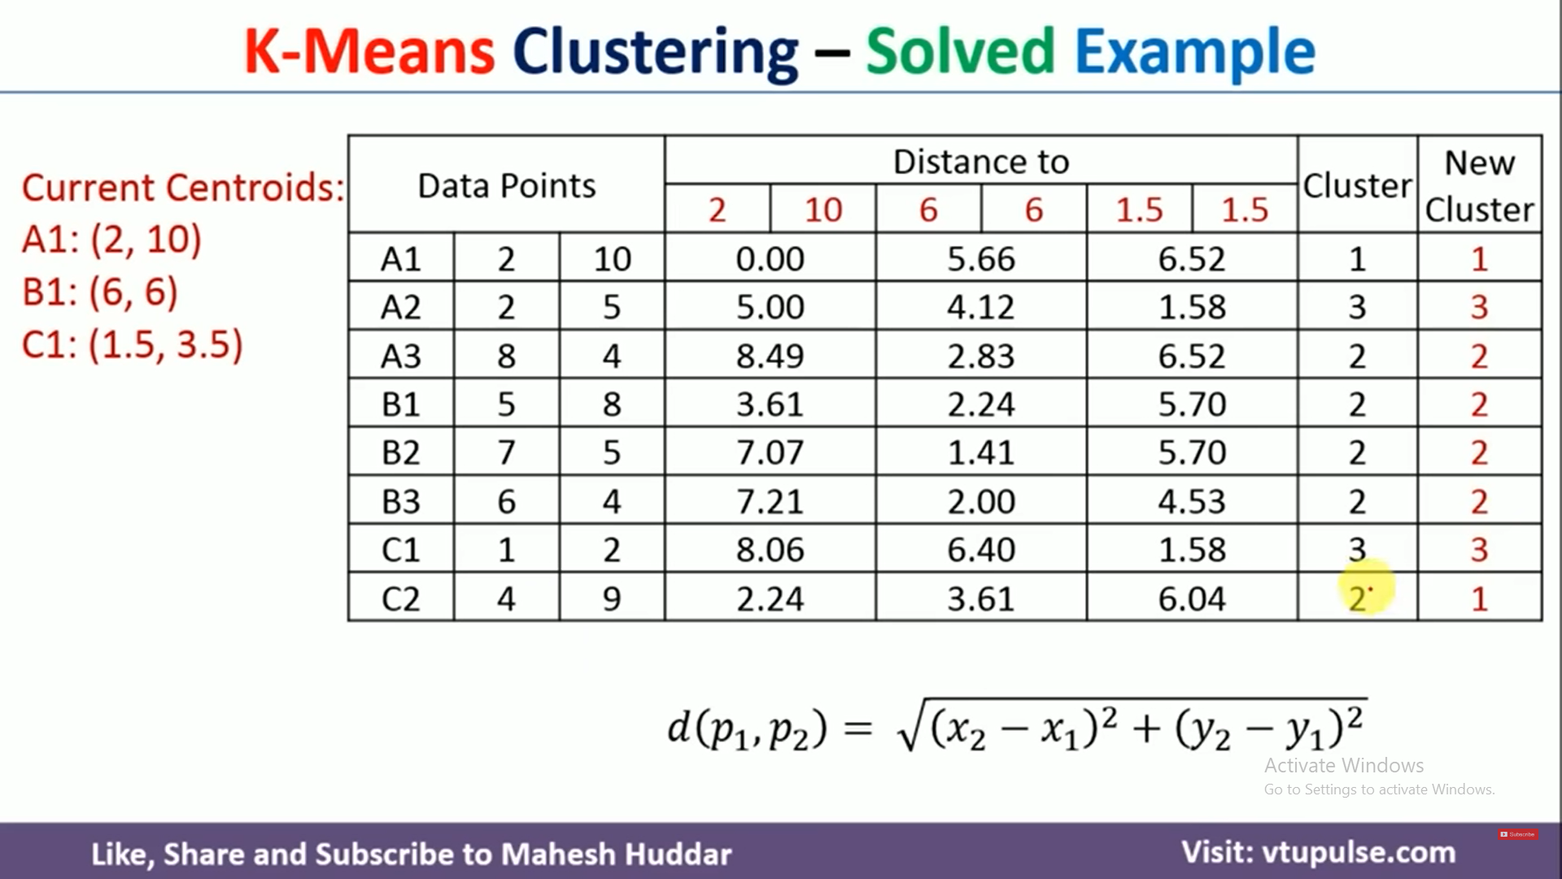

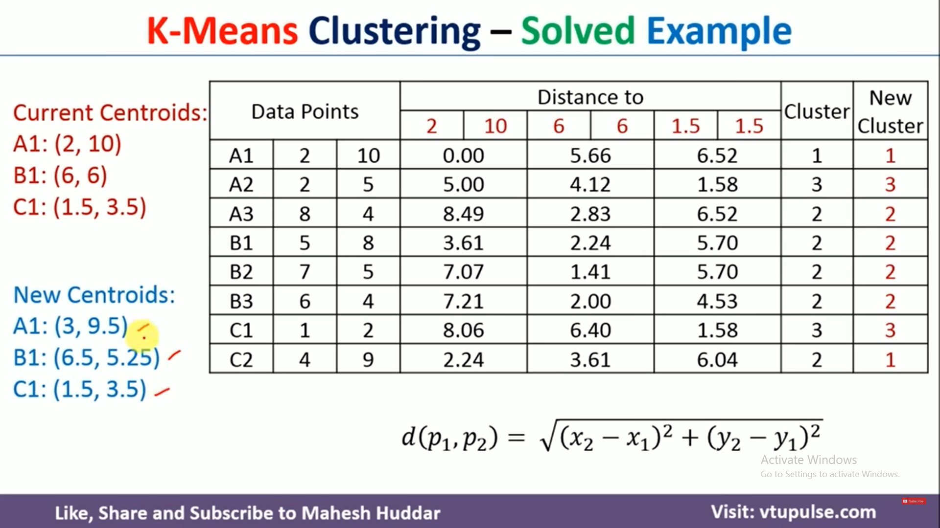

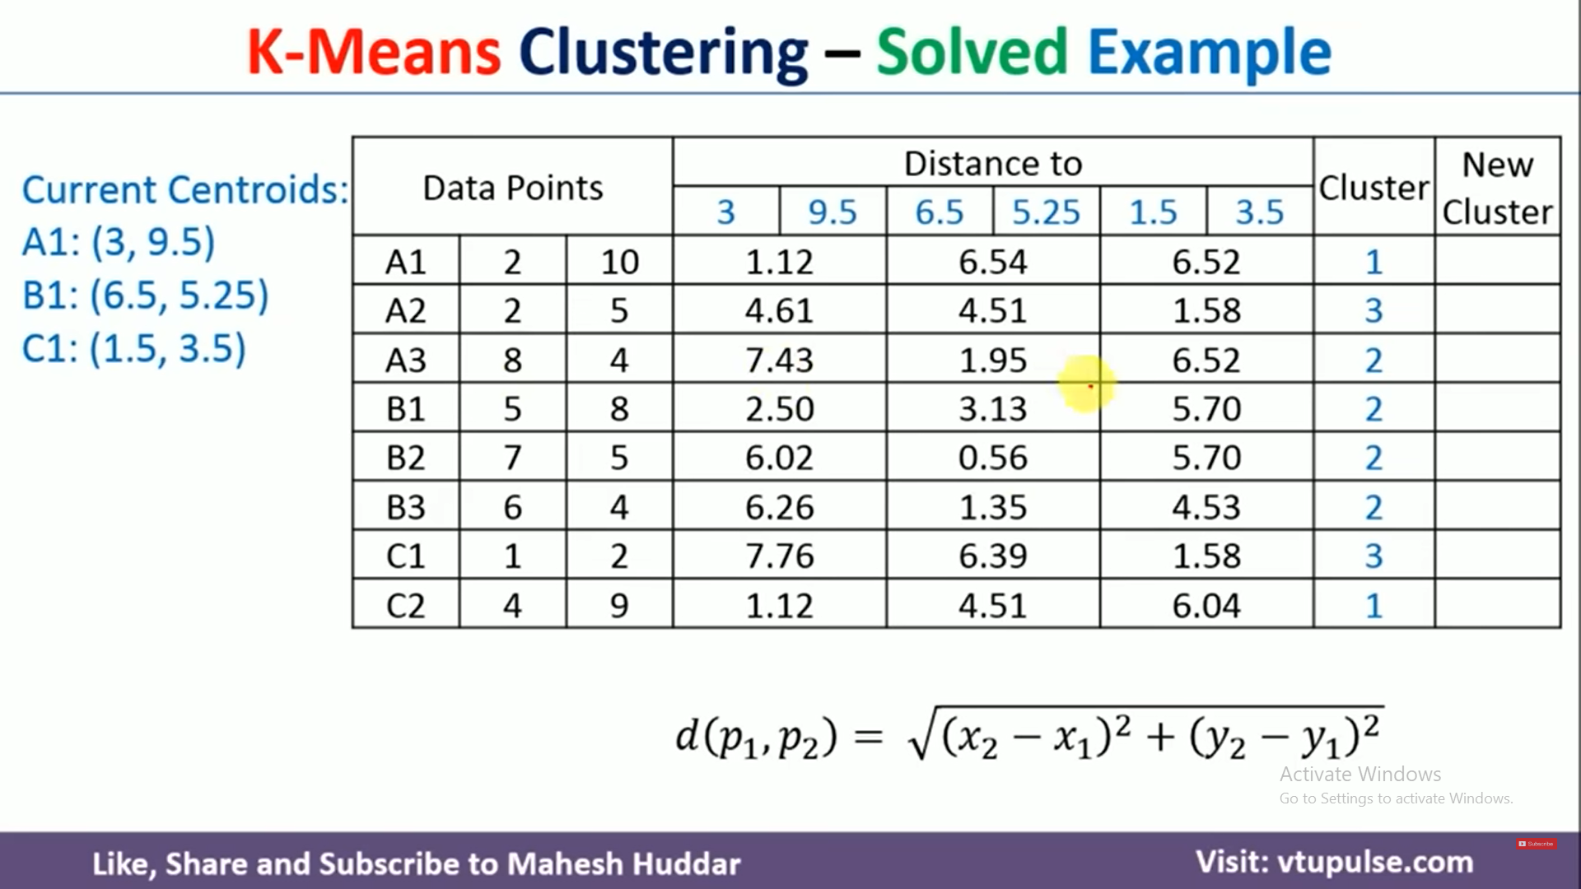

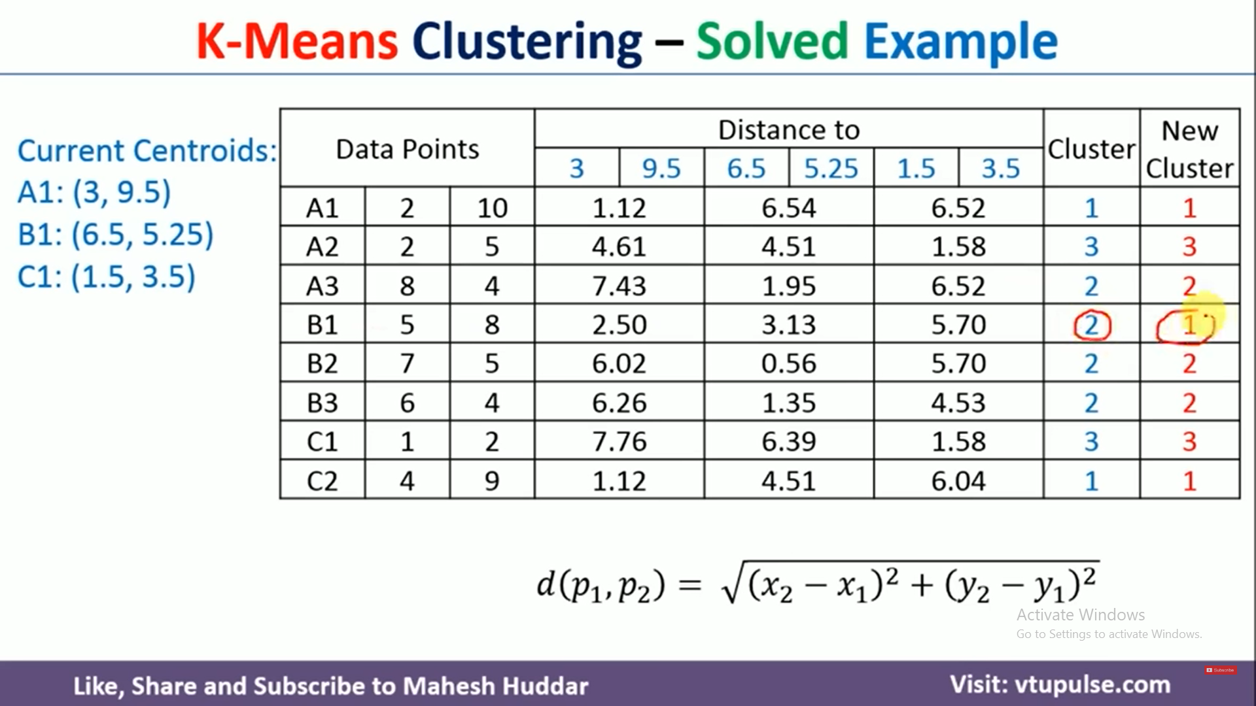

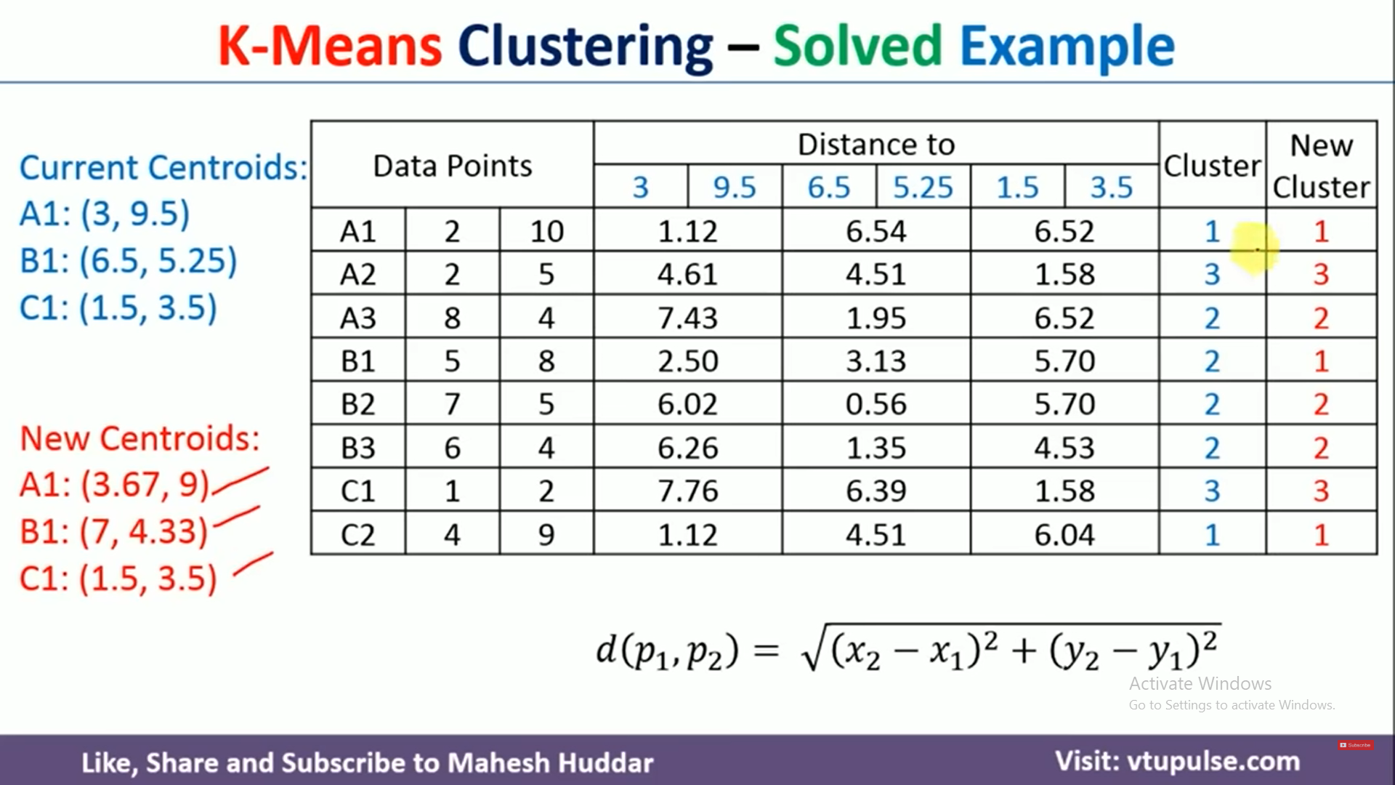

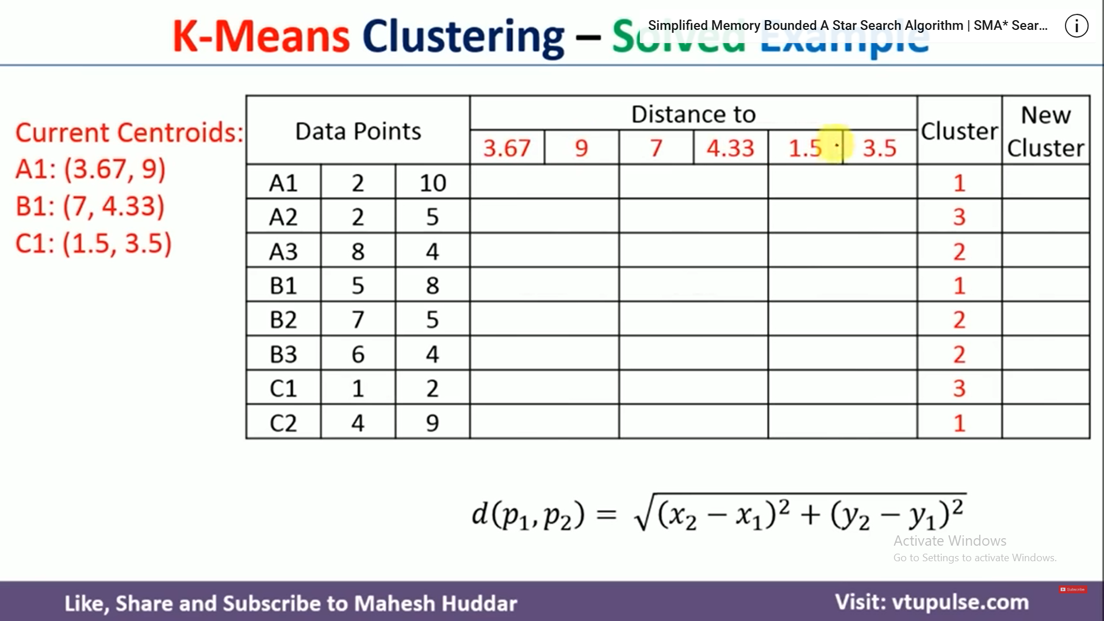

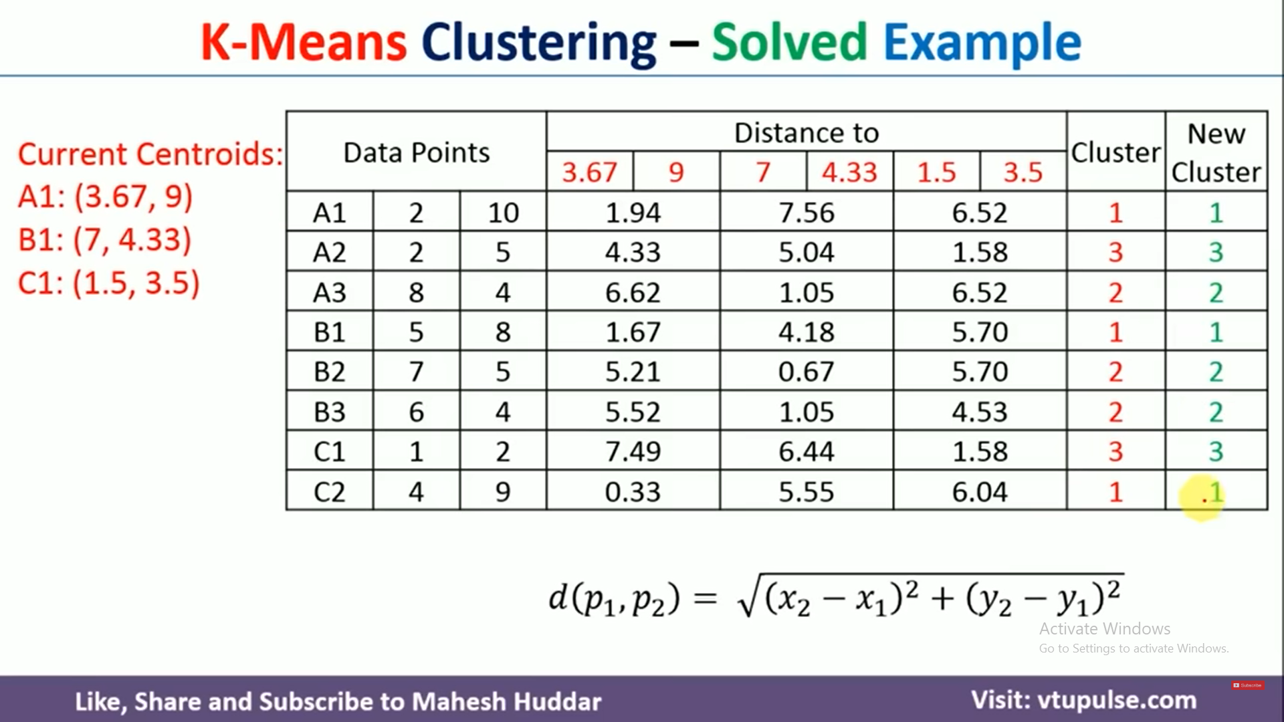

K- Medoids
K-medoids is a partitional clustering algorithm which is slightly modified from k-means algorithms
In K-means we choose means as a centroids but in k-medoids, data points are chosen to be mediods
K-medoids algorithm
- Initially select k random points as the medoids from the given n data points of the data set
- Associate each data point to the closet medoids by using any of the most common distance metrics.
- Calculate total cost as the sum of the distances of the data points from the assigned medoids
C= $\sum_{ci}{\sum{|p_{i}}}- c_{i}$|
- Swap the one medoid point with non-medoid point and recalculate the cost

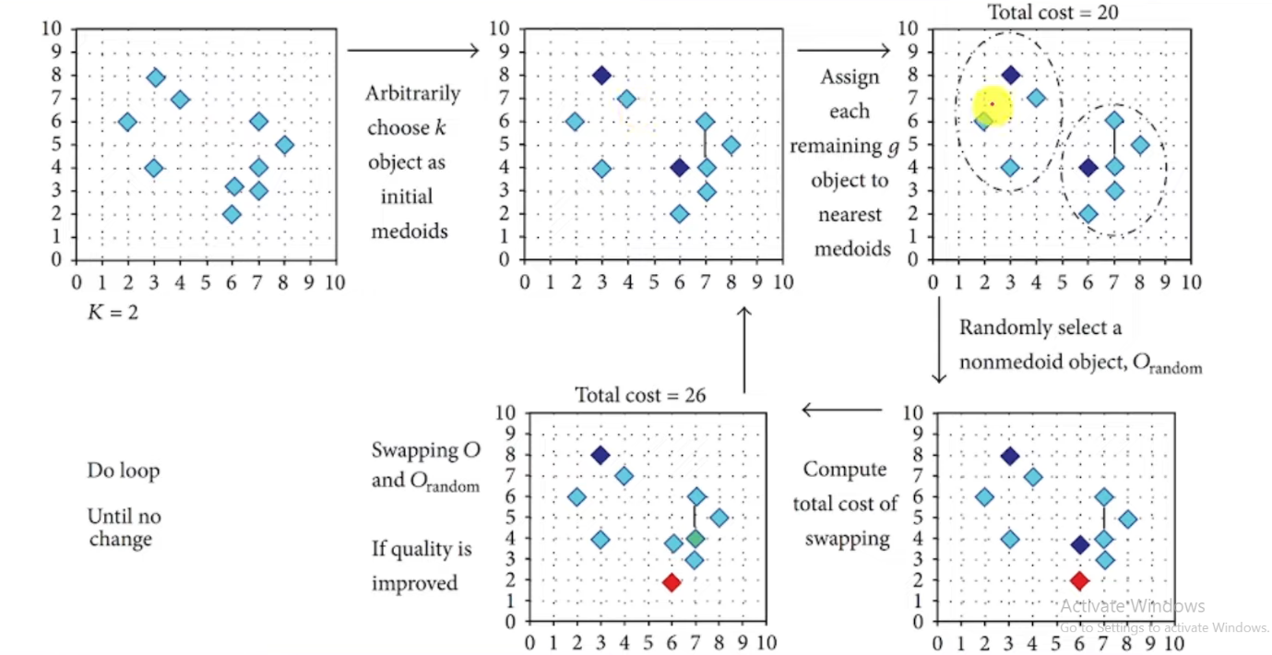
Advantages
- It is simple to understand and easy to implement
- K-medoid algorithm is fast and converges in fixed number of steps
- K-medoid is less sensitive to outliers and partitioning algorithms

Disadvantages
- The main disadvantages of k-medoids algorithm is that it is not suitable for clustering non-spherical(arbitrarily shaped)group of objects
- It may obtain different results for different runs on the same dataset because first k-medoids are chosen randomly

Numerical on K-Medoid
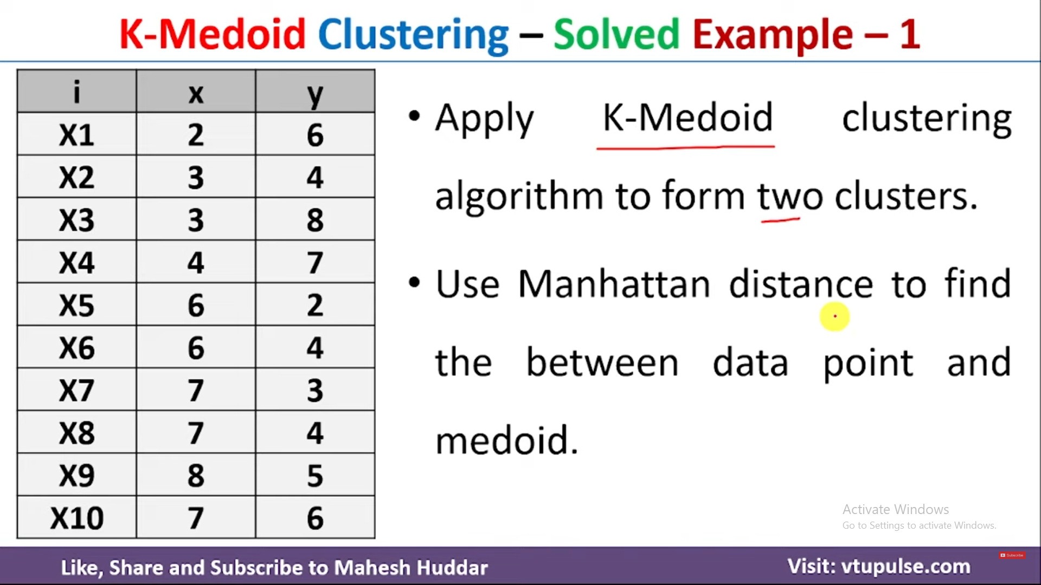

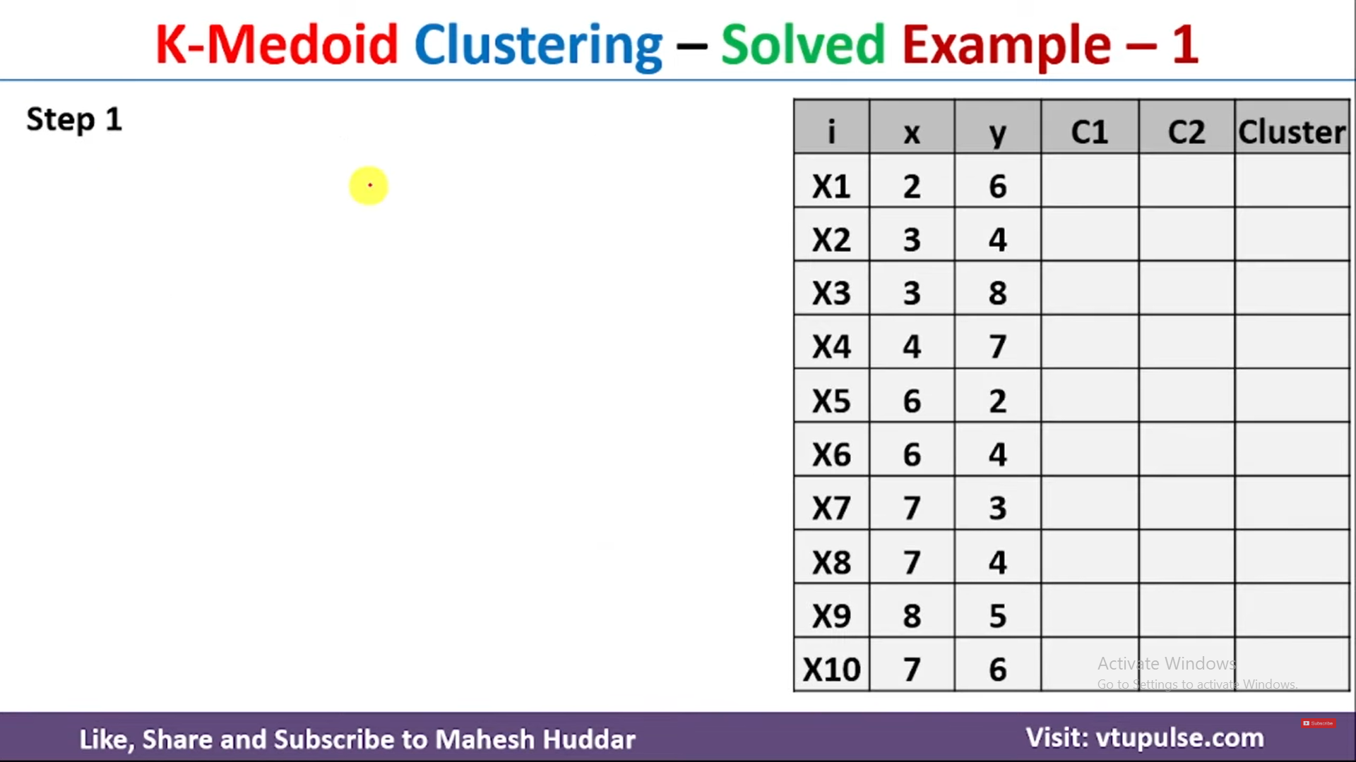
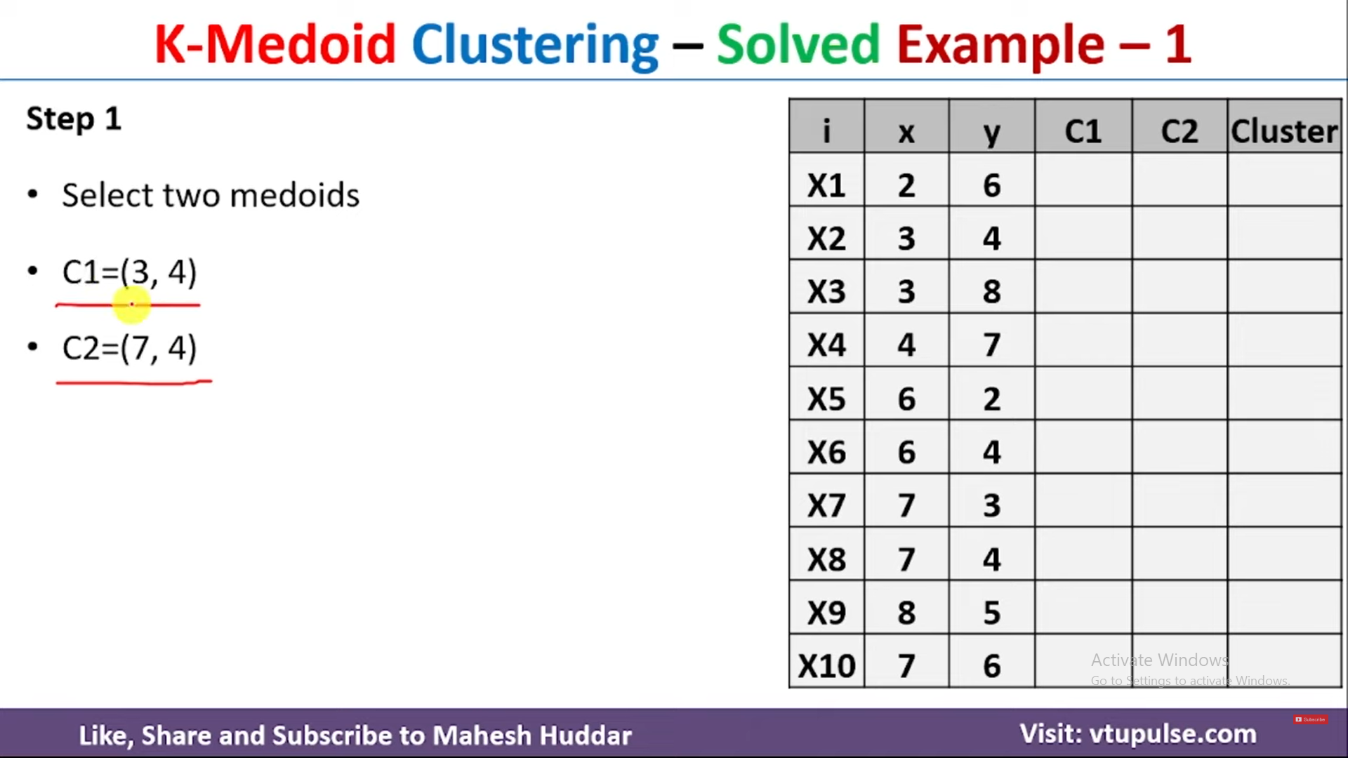

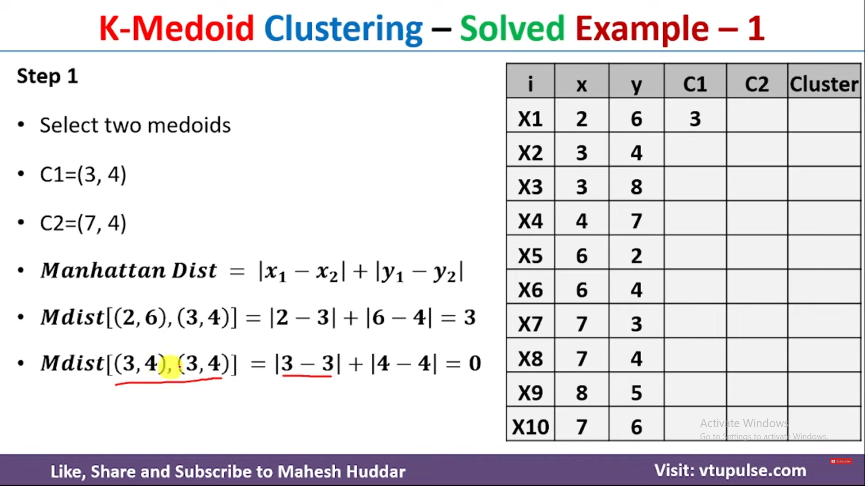

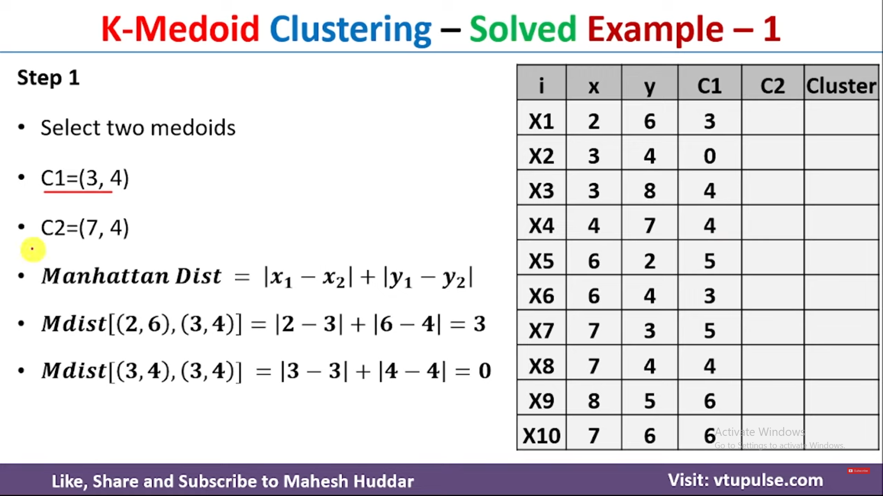

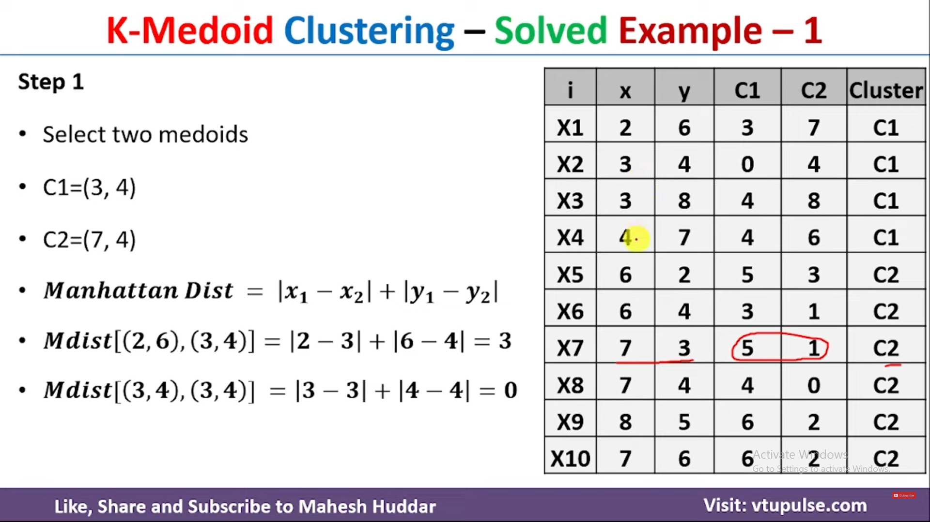

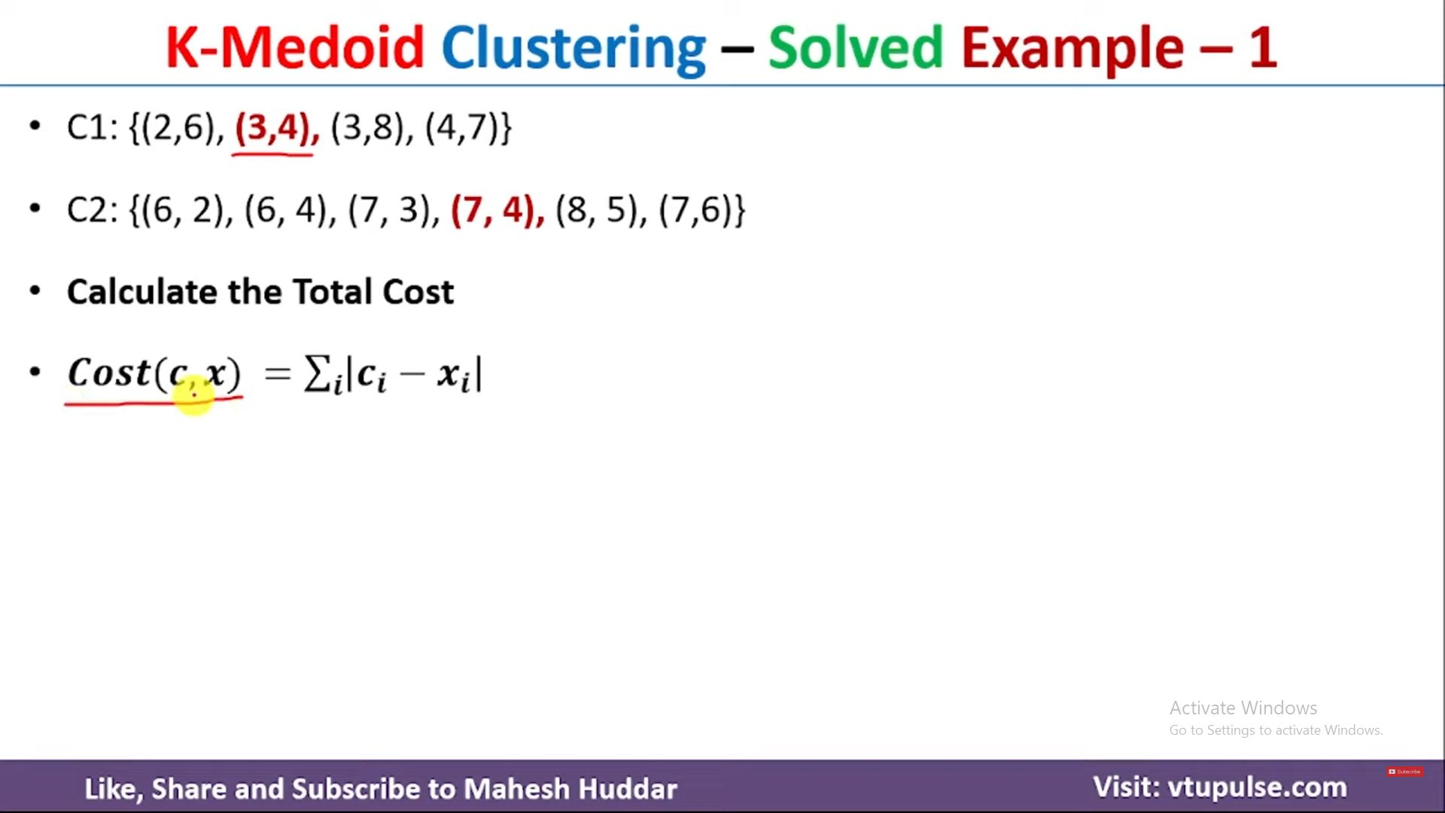

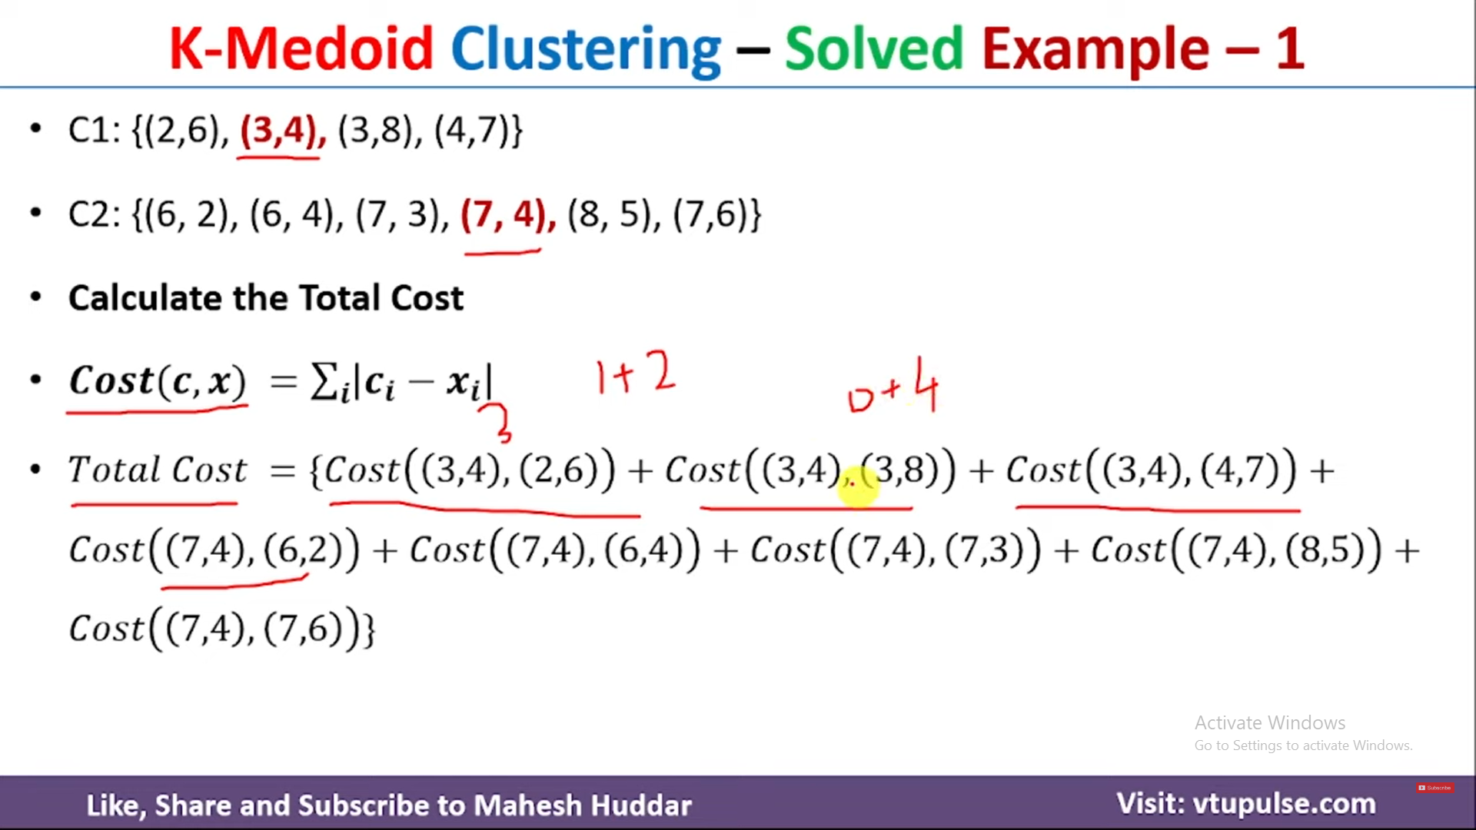

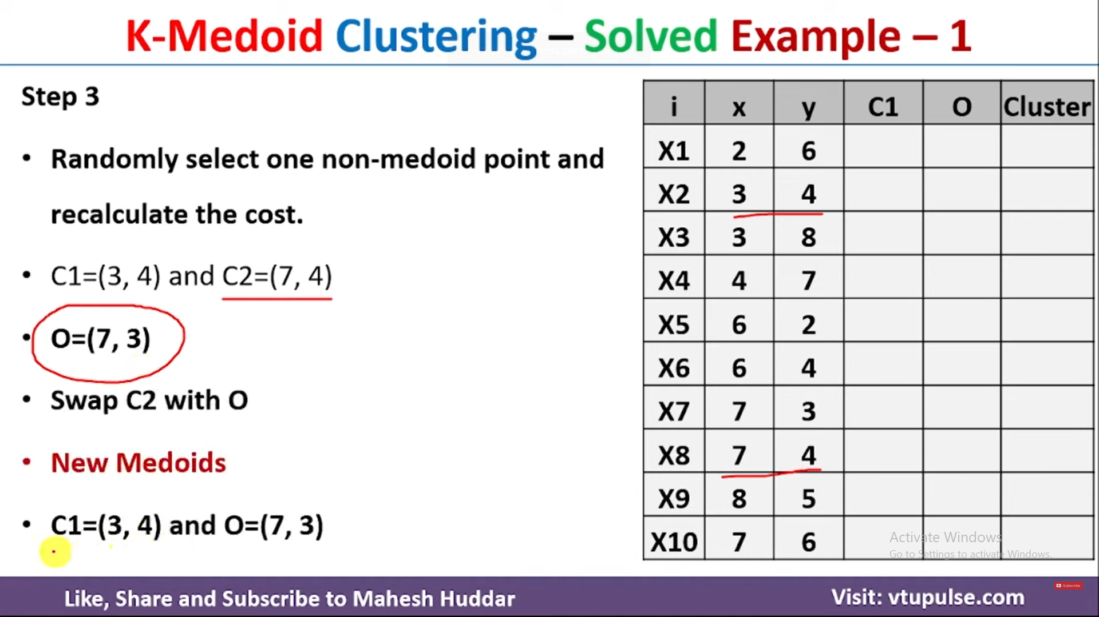

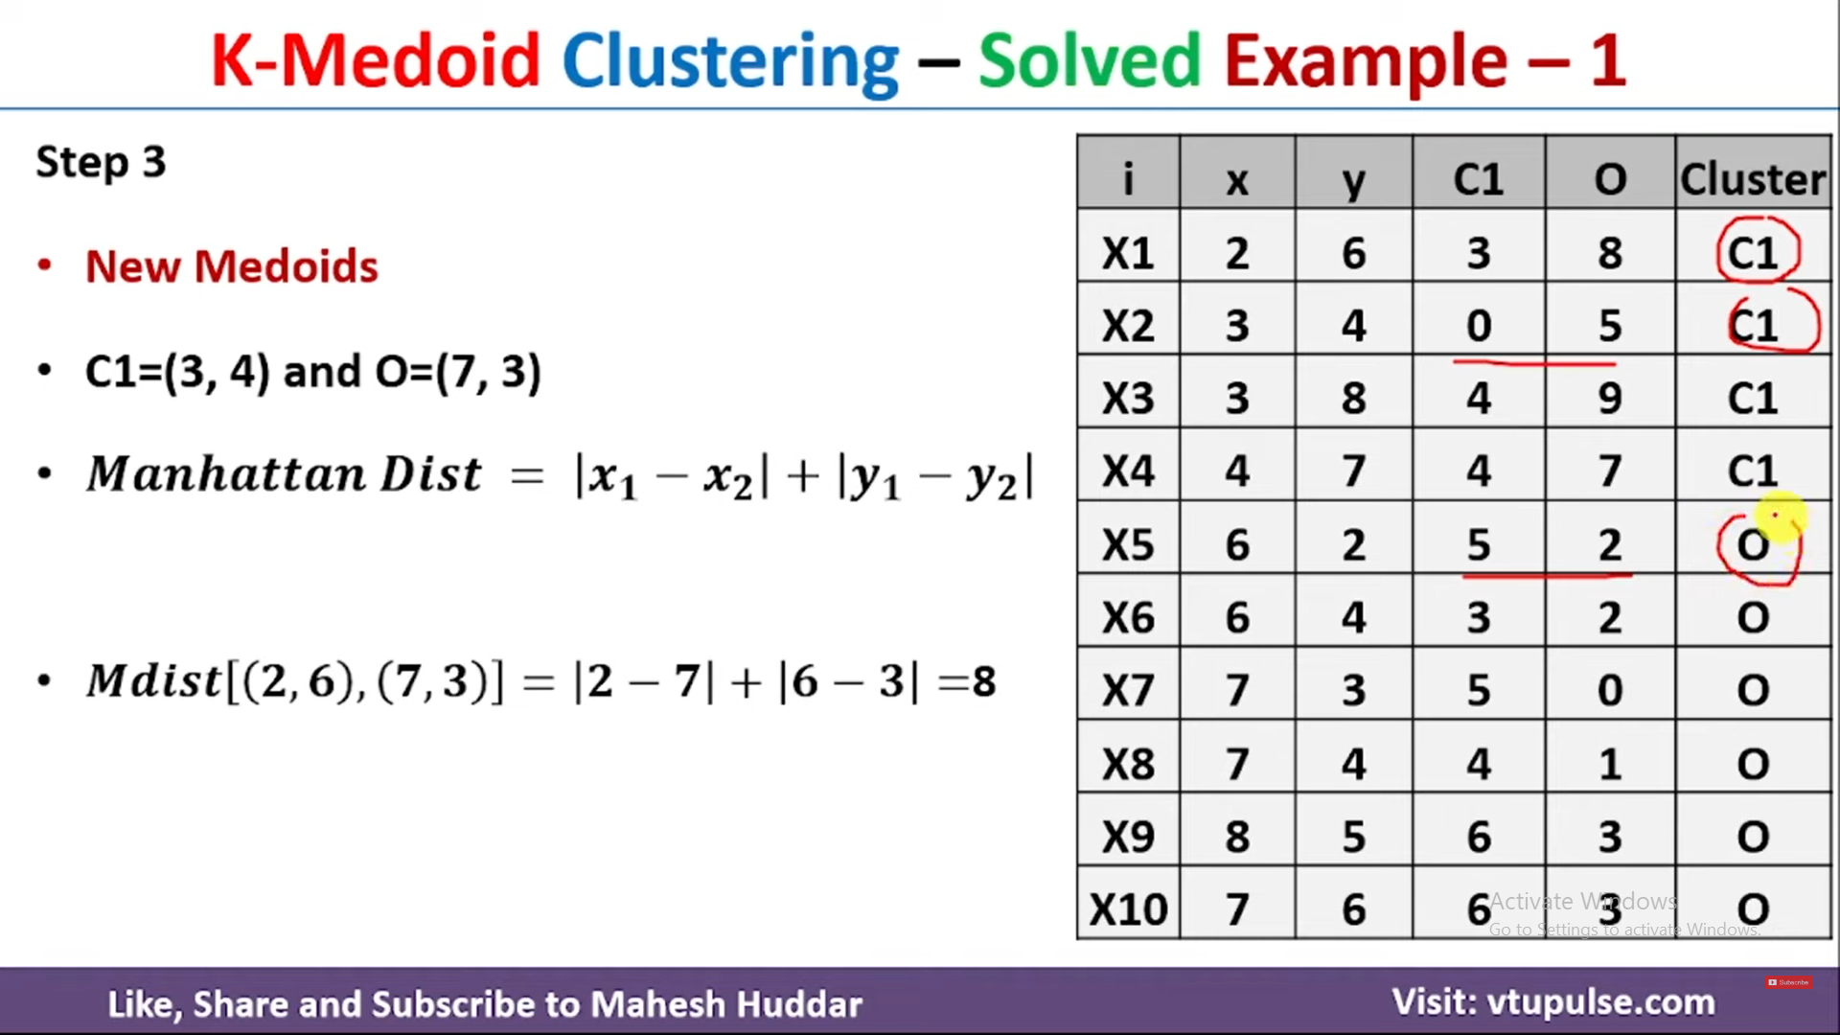

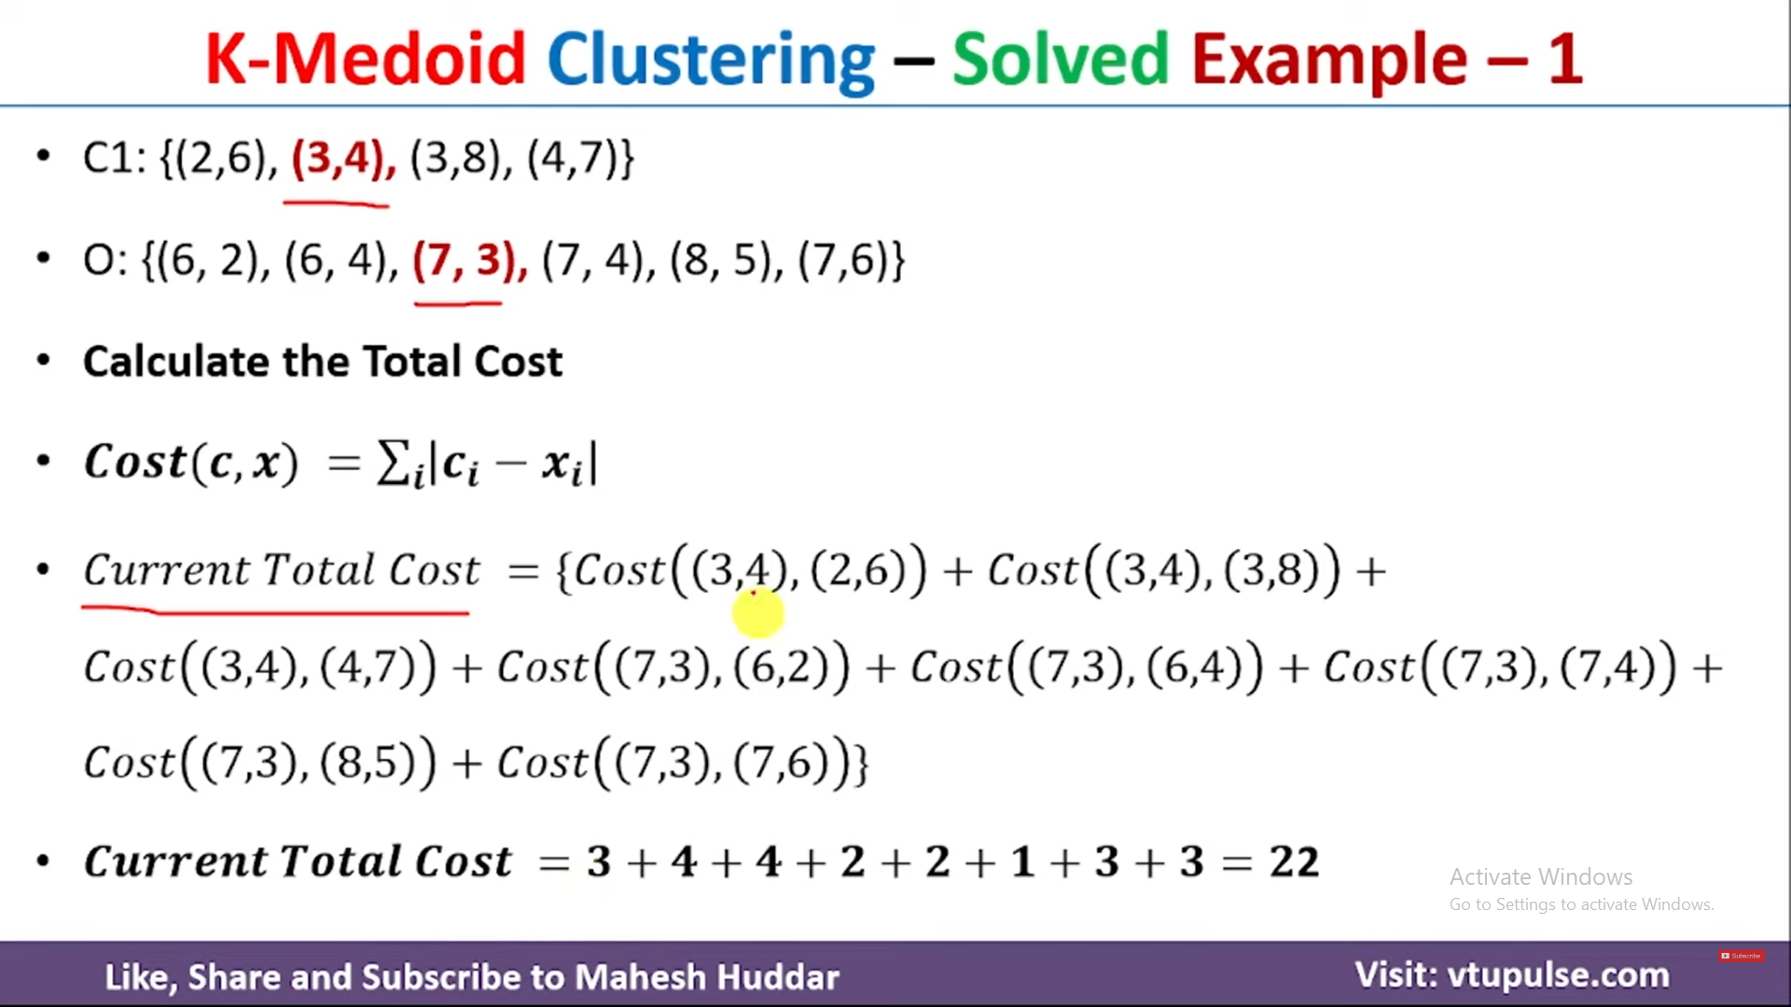

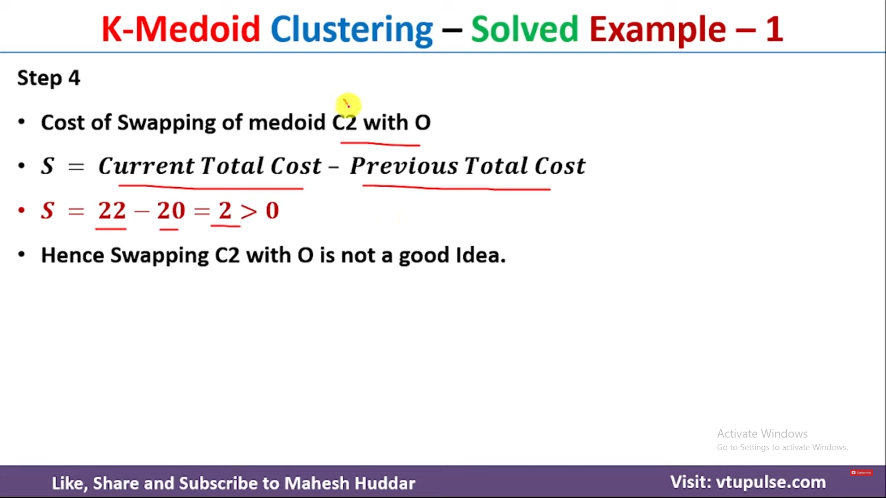

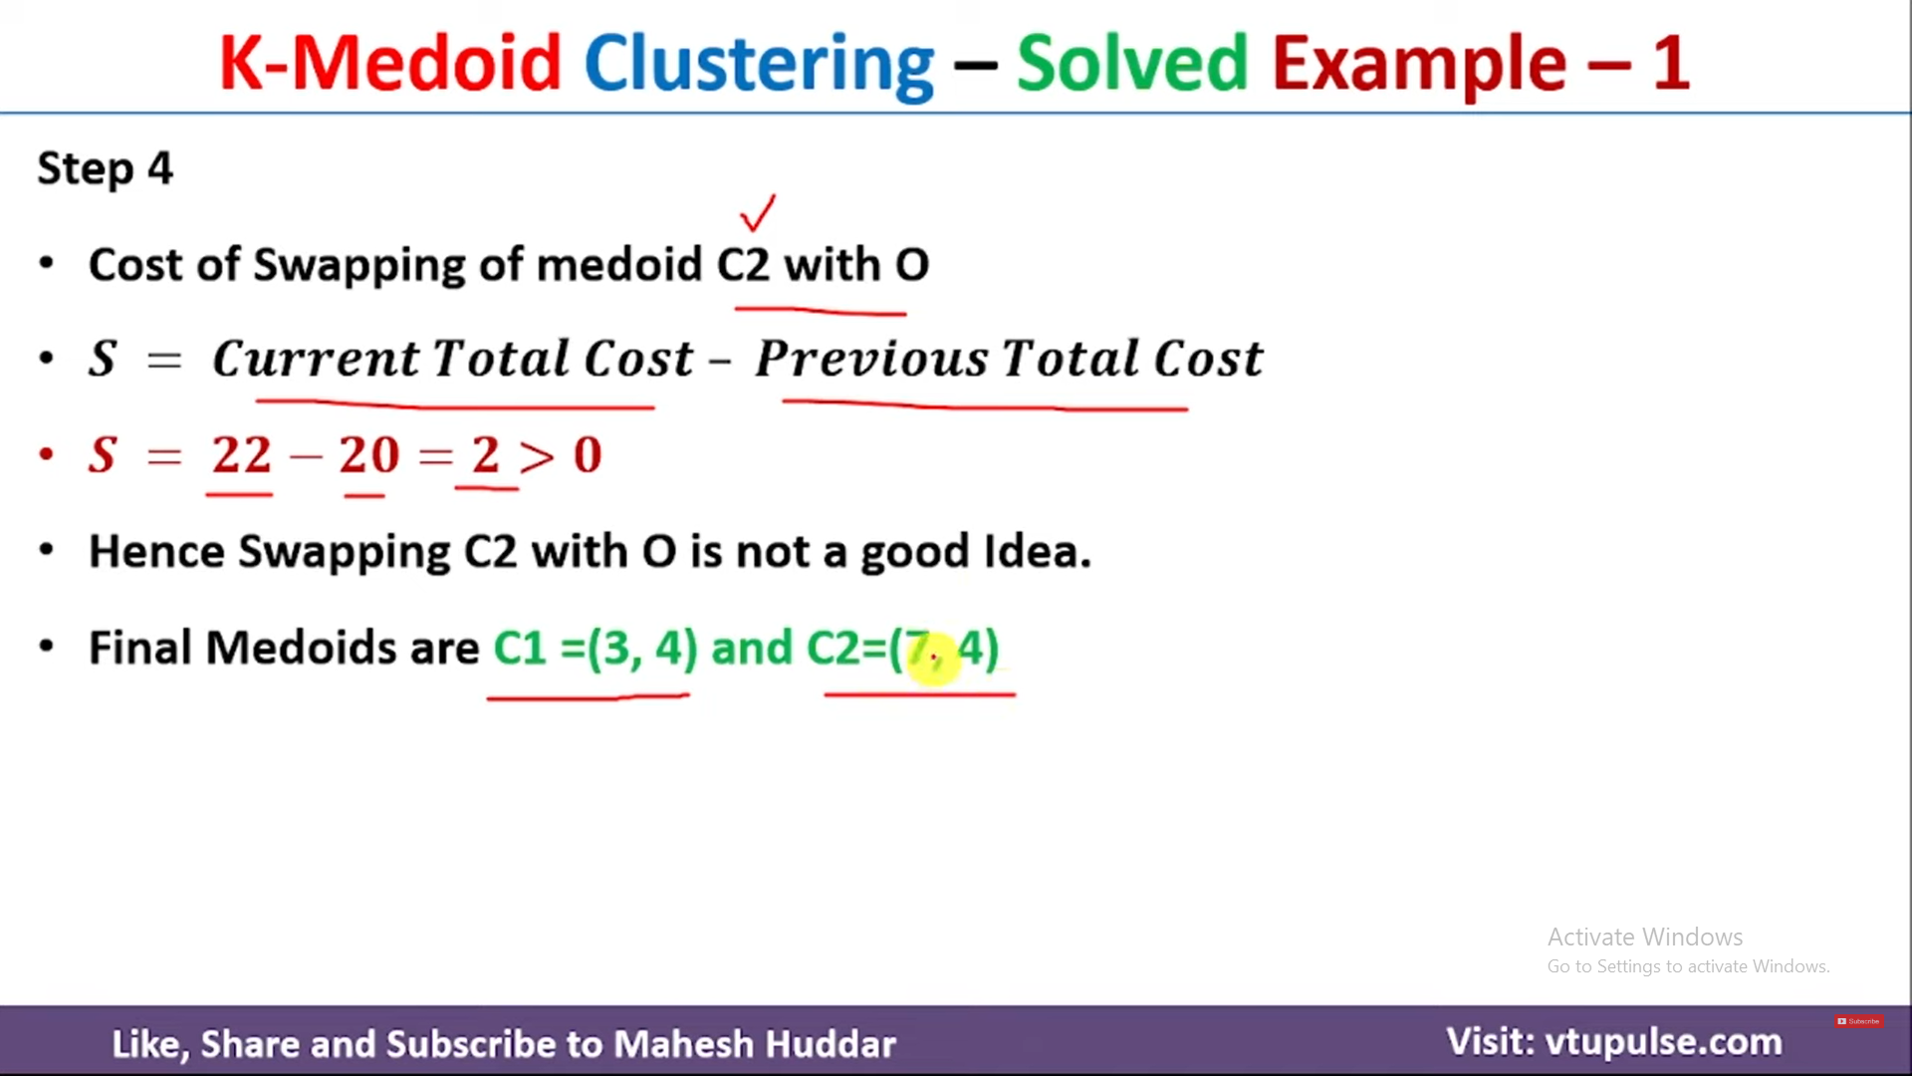

Hierarchical clustering
Hierarchical clustering is another unsupervised machine learning algorithm
It is used to group unlabeled dataset into cluster and also known as hierarchical clustering or HCA.
In this algorithm we develop the hierarchy of cluster in the form of tree, and this tree shaped structure is known as dendrogram
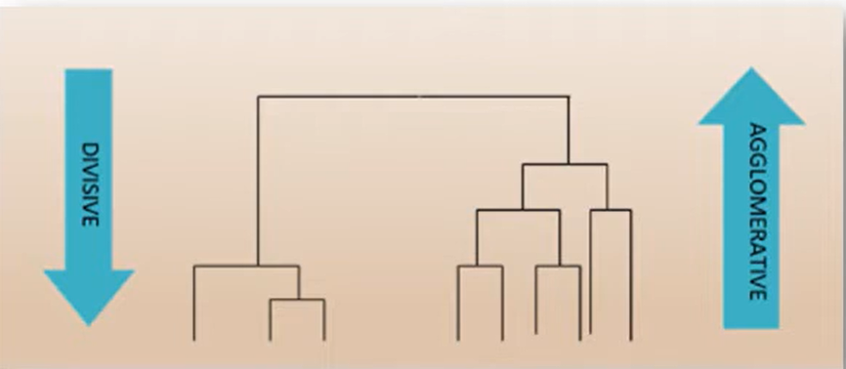

Why hierarchical clustering?
As we already have K-means clustering Algorithm
So, as we have seen in the k-means clustering we have some challenges with algorithms, which are pre-determined number of cluster and it always tries to create cluster of similar size.
To solve these two challenges, we can option for hierarchical clustering algorithm because in this algorithm, we don’t need to have knowledge about pre-defined number of cluster.

Types of Hierarchical clustering
- Agglomerative Clustering: Agglomerative is a bottom up approach, in which the algorithm starts taking all the data points as a single cluster is left.
- Divisive cluster: It is reverse of agglomerative algorithm as it is top-down approach.
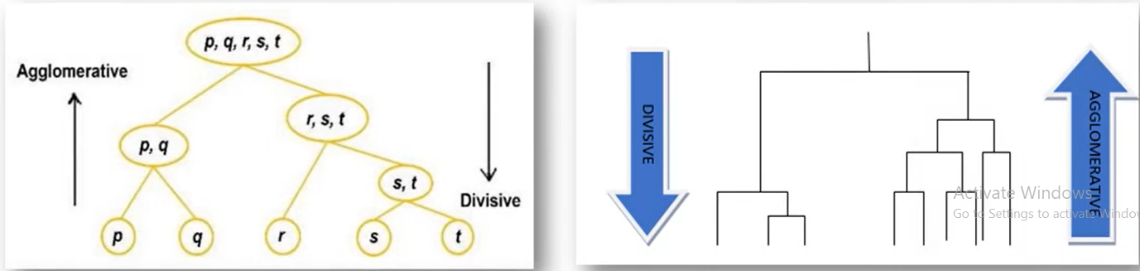

What is dendrogram?
A dendrogram is a type of tree diagram showing hierarchical relationship between different sets of data.
Dendrogram is a memory of hierarchical clustering algorithm
Just by looking at the dendrogram you can tell how the clusters are formed.
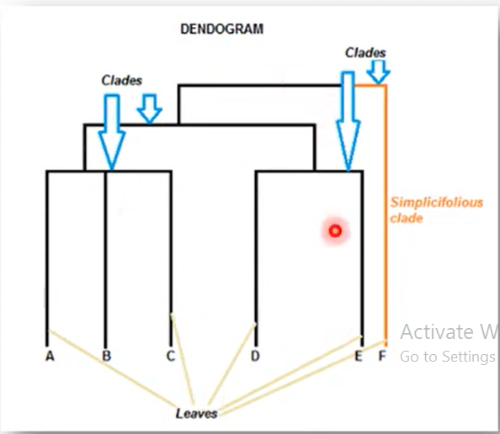

Example

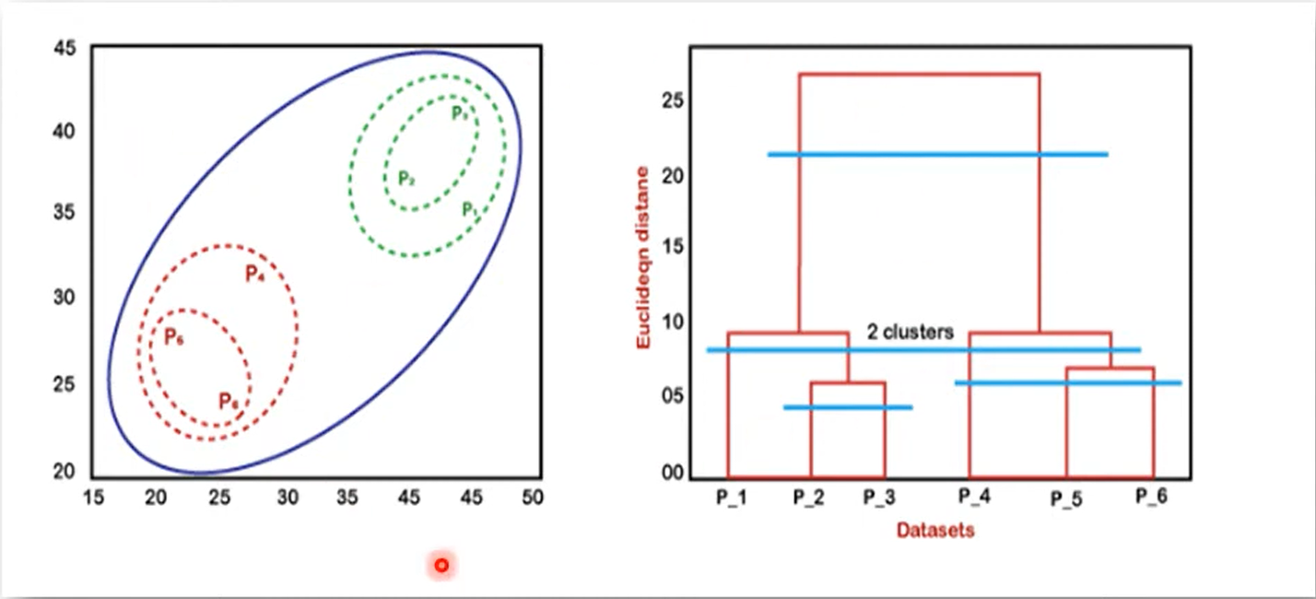
In the above diagram, left part is showing how cluster is created in agglomerative clustering and right part is showing the corresponding dendrogram.

Firstly, datapoints P2 and P3 are combined together and form cluster, corresponding dendrogram is created, which connects P2 and P3 with rectangular shape.
The height is decided according to the Euclidean distance between data points.
In the next step P5 and P6 form a cluster, and the corresponding dendrogram is created.
It is higher than that of previous, as Euclidean distance between P5 and P6 is little bit greater than the P2 and P3.
Again two new dendrogram are created that combine P1,P2,P3 in one dendrogram, and P4,P5,P6 into another dendrogram.
At last final dendrogram is created that combines all the data points together.

